**Gucci Glasses Eyecare Store**

Chevannese Ellis 2301109

Faculty of Engineering and Computing, University of Technology

CIT2011: Web Programming

Individual Assignment 2

Miss Christine Anuli

Day/Time of Class: Wednesdays 8am

Due Date: October 17, 2024

# Storyboard

## wireframe, sitemap, and mockups, etc.

Wireframe

Index Page

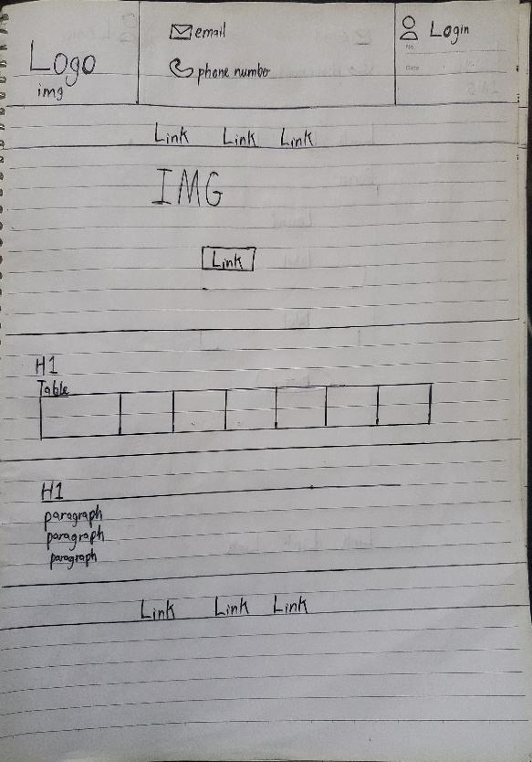

About Us

Login Page

Product/Services Page

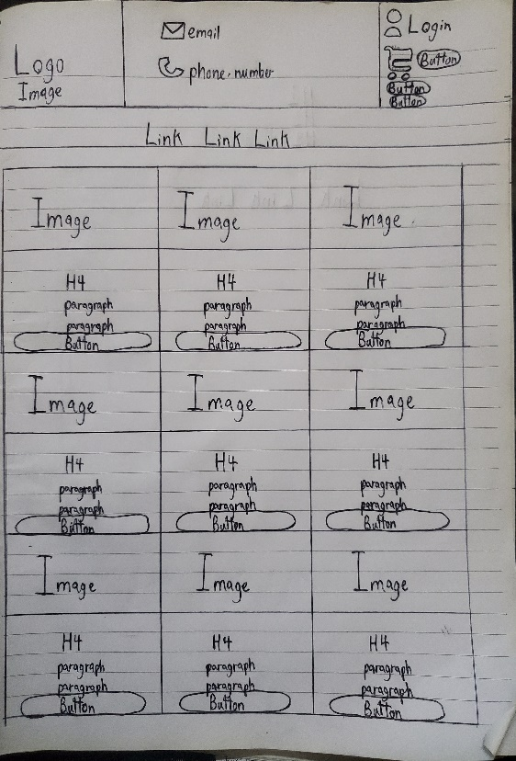 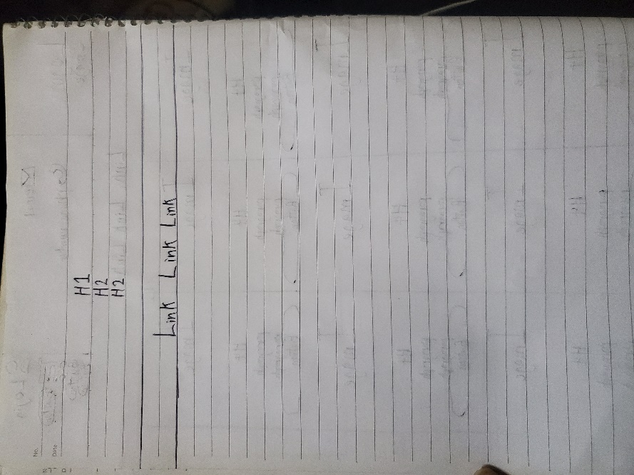

Invoice Page

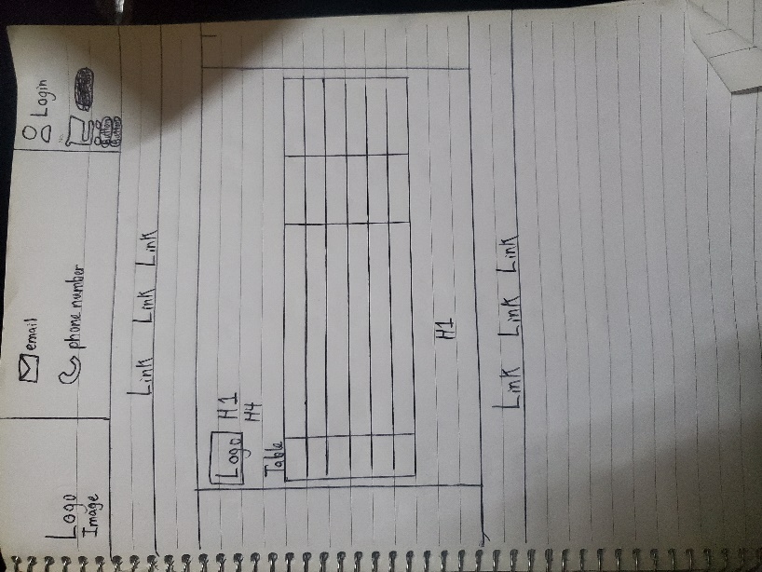

Error Page

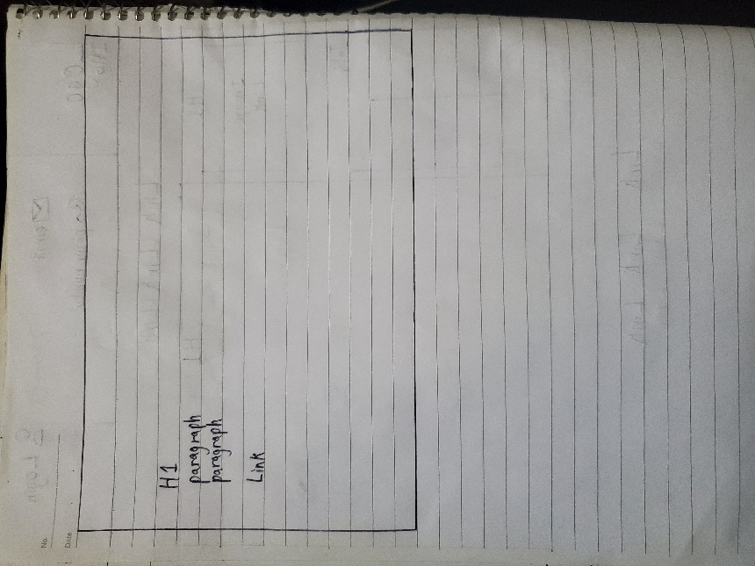

Mockup

Index Page

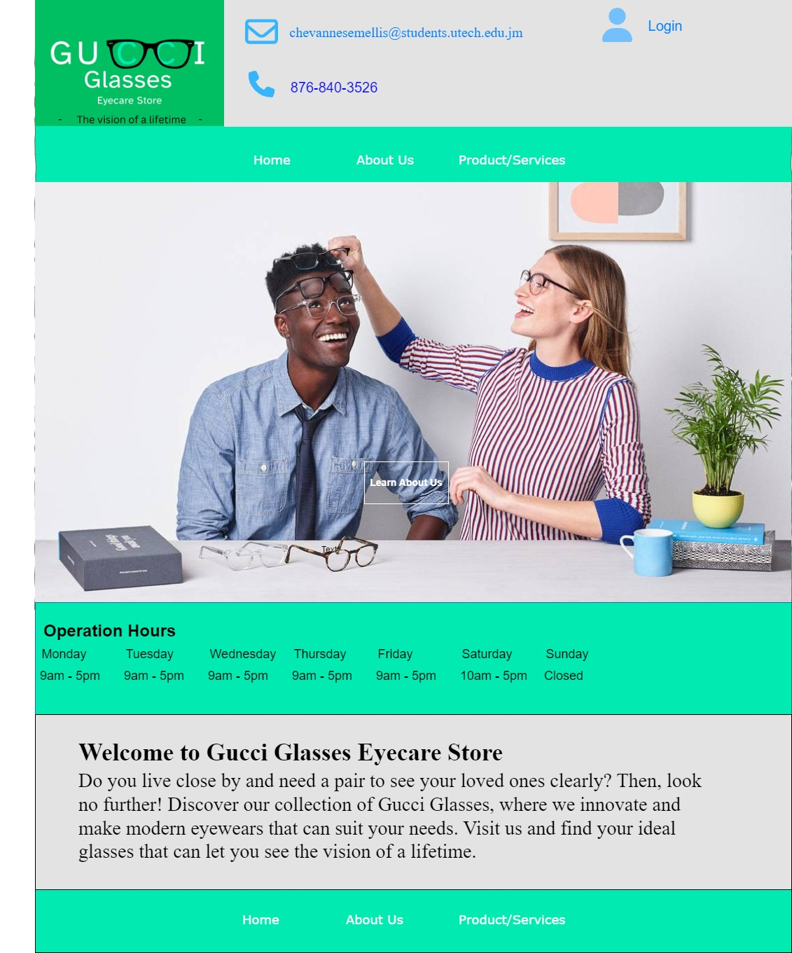

About Us

Login Page

Product/Services

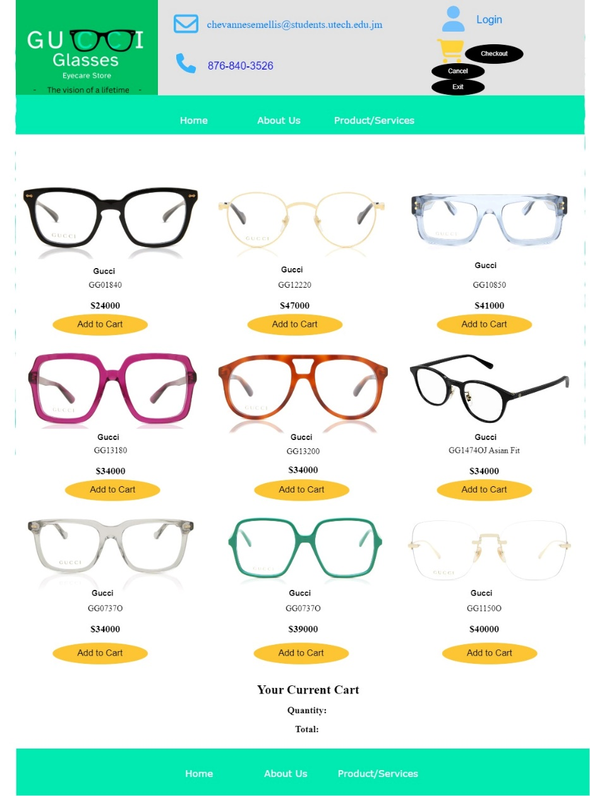

Invoice Page

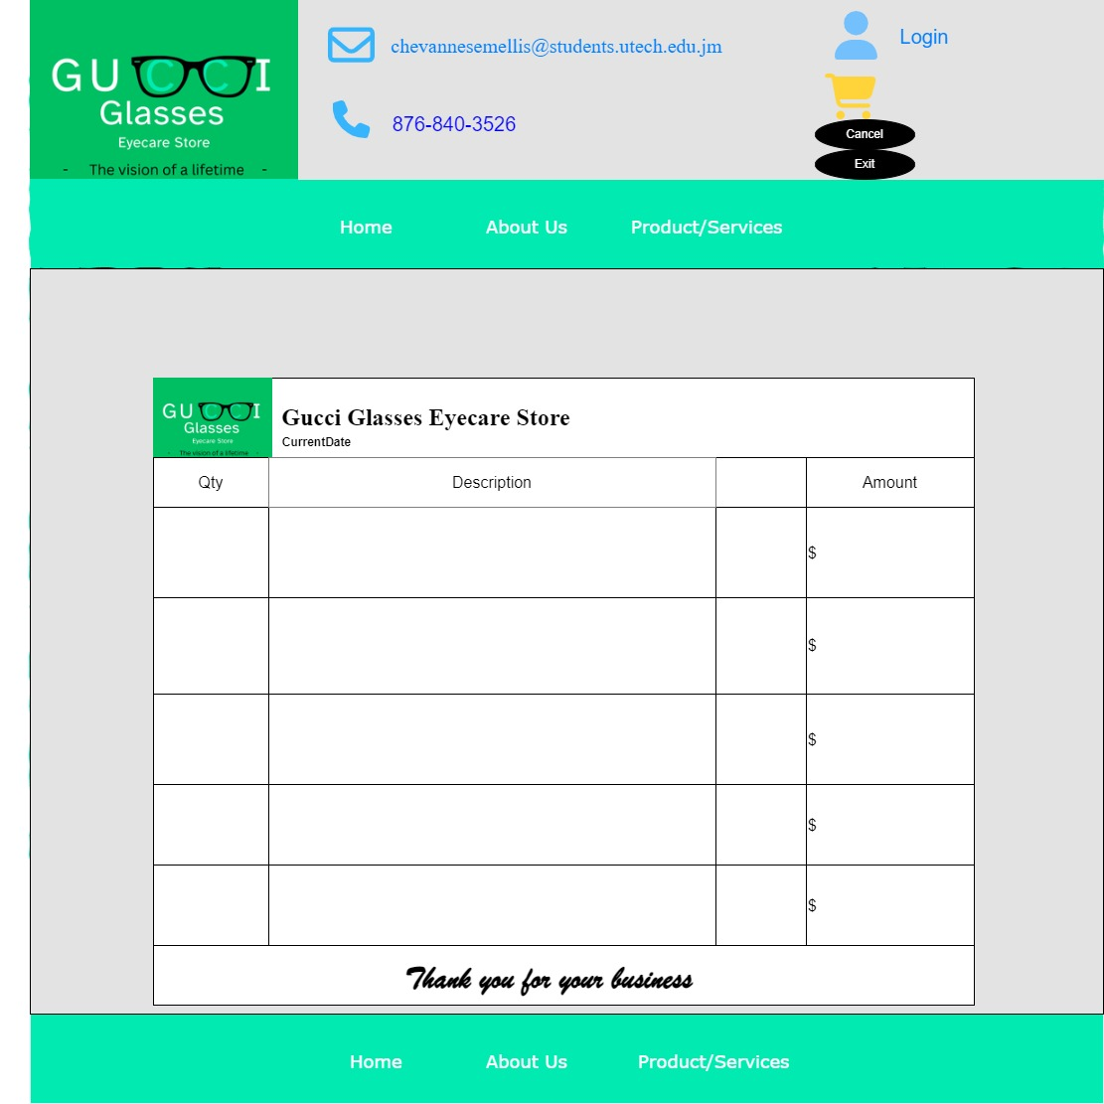

Error Page

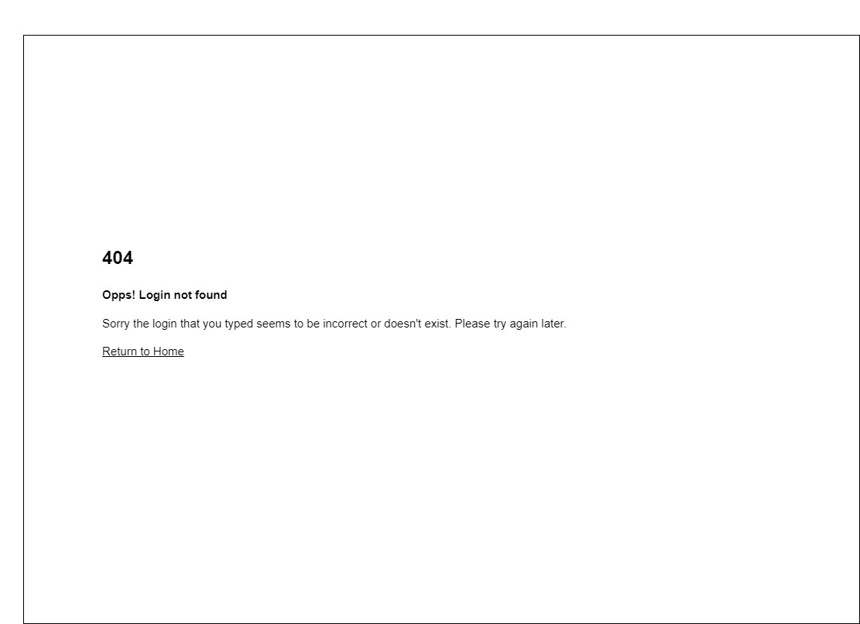

Sitemap

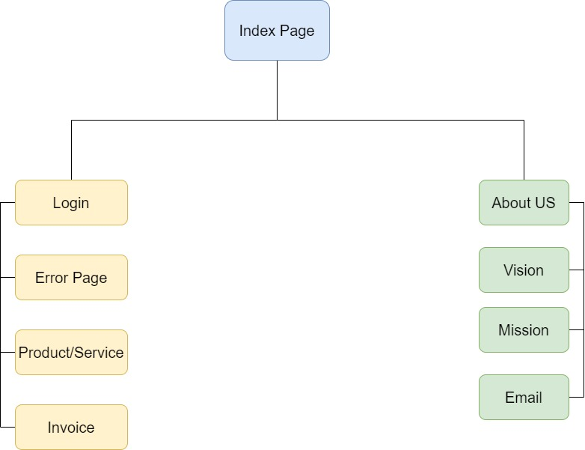

Colour Palette

## A description of your business, logo, slogan, mission statement, vision, statement, etc

Gucci Glasses Eyecare Store is a glasses business that offers high quality modern Gucci glasses frames to individuals. It excels at fashion and function.

The logo of the company represents improved and renewed eyesight as the letters “CC” in the word “GUCCI” has a light green glow to it with glasses hovering around it. It is simple and demonstrates clearly that it is an eyecare store.

The slogan of the business is “The vision of a lifetime”. It means that the glasses serve a greater purpose as they allow wearers to become confident in themselves and strive on a clear path. Other people will be able to distinguish the glasses and become inspired by such magnificence.

The vision of Gucci Glasses Eyecare Store is to be a place where people can come and discover their ideal glasses that they love. The mission of Gucci Glasses Eyecare Store is to develop self-aware wearers who have the desire of lifelong learning and maintaining healthy eyesight by doing regular checkups by our loving and caring staff that are equipped with the latest technologies.

## Include a brief justification of the color palette you chose for your website, ie the psychology of color in web design and marketing. <https://www.youtube.com/watch?v=8J0nbuunDXc>

The colour platinum represents rarity, strength and elegance. I used this colour because the glasses that are sold by Gucci Glasses Eyecare Store are special, durable, modern glasses made that charm the wearer beholding it and others seeing it as well. I found it suitable on the website because it brings a professional feel to the website.

The colour aquamarine inspires feelings of relaxation, weightlessness and purity. The reason why this colour was used is because it helps to ease the tension of users who are selecting their glasses. It promotes peacefulness and trust, inspires patience and helps to calm the senses.

The colours light green and dark green are associated with health, growth, and abundance. They are also the easiest on the eyes and tend to allow users to keep track on the website without getting distracted.

The colour white is associated with cleanliness and purity. It is used mostly on invoice and product/services page to prevent the user from being overwhelmed and focus on what glasses he/she desires.

## Description of the intended audience for your website.

The intended audience for the website is Prescription Glasses Wearers. These are people that suffer from either nearsightedness, farsightedness or astigmatism. They rely on and require appropriate quality prescription lenses to see, read, drive, and screen usage.

# Free Hosting Link

<https://chevannese.github.io/2301109IA2.github.io/>

# Reference

AB Vision Eyecare. (n.d). Frames.

<https://www.abvisionjamaica.com/>

Anjjar, B. (2023). removeItem(). Codecademy.

<https://www.codecademy.com/resources/docs/javascript/storage/removeItem>

Bro Code. (2024, January 1). JavaScript Full Course for free 🌐 (2024). YouTube.

<https://www.youtube.com/watch?v=lfmg-EJ8gm4&t=37102s>

Canva. (n.d).

<https://www.canva.com/>

Coolors. (n.d). The super fast color palettes generator.

<https://coolors.co/>

Envato. (2021, March 18). Color Psychology | Red, Blue, Yellow, Green, Pink, White, Black, Gray and Gold. YouTube.

<https://www.youtube.com/watch?v=8J0nbuunDXc>

envatomarket. (n.d). Specs Shopify Theme.

<https://preview.themeforest.net/item/specs-glasses-store-ecommerce-shopify-os-20/full_screen_preview/54408725>

Font Awesome. (n.d). Take the hassle out of icons out your website.

<https://fontawesome.com/>

SmartBuyGlasses. (n.d). Gucci® Glasses.

<https://www.smartbuyglasses.co.uk/designer-eyeglasses/Gucci/>

SuperSimpleDev. (2024, May 9). JavaScript Tutorial Full Course - Beginner to Pro (2024). YouTube.

<https://www.youtube.com/watch?v=EerdGm-ehJQ&t=46268s>

Web Dev Simplified. (2018, October 4). JavaScript Shopping Cart Tutorial for Beginners. YouTube.

<https://www.youtube.com/watch?v=YeFzkC2awTM>

W3Schools. (n.d). JavaScript Tutorial.

<https://www.w3schools.com/js/default.asp>